**Exercise 1: Control Structure**

**Scenario 1:** The bank wants to apply a discount to loan interest rates for customers above 60 years old.

* + Question: Write a PL/SQL block that loops through all customers, checks their age, and

if they are above 60, apply a 1% discount to their current loan interest rates.

**Scenario 2:** A customer can be promoted to VIP status based on their balance.

* + Question: Write a PL/SQL block that iterates through all customers and sets a flag IsVIP

to TRUE for those with a balance over $10,000.

**Scenario 3:** The bank wants to send reminders to customers whose loans are due within the next 30 days.

* + Question: Write a PL/SQL block that fetches all loans due in the next 30 days and prints

a reminder message for each customer.

**Scenario 1:**

--Scenario 1- Apply 1% discount to age>60

BEGIN

FOR rec IN (

SELECT c.cus_id, l.loanid

FROM CUSTOMERS1 c

JOIN LOANS1 l ON c.cus_id = l.cus_id

WHERE c.age > 60

) LOOP

UPDATE LOANS1

SET INT_RATE = INT_RATE - 1

WHERE loanid = rec.loanid;

DBMS_OUTPUT.PUT_LINE('1% discount applied to customer ID: ' || rec.cus_id);

END LOOP;

COMMIT;

END;

/

SELECT * FROM LOANS1;

**Output Scenario1:**

**Scenario 2:**

--Scenario 2-Promote to vip if balance>10000

BEGIN

    FOR rec IN(SELECT * FROM CUSTOMERS1)LOOP

    IF rec.balance>10000 THEN

    UPDATE CUSTOMERS1

    SET IsVIP='TRUE'

    WHERE cus_id=rec.cus_id;

    DBMS_OUTPUT.PUT_LINE(rec.name || 'promoted to vip');

    END IF;

    END LOOP;

    END;

    /

SELECT * FROM CUSTOMERS1;

**Output Scenario2:**

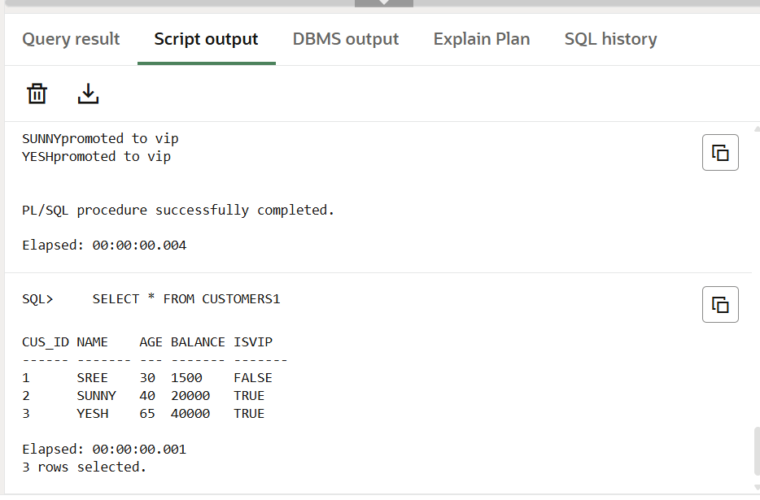

**Scenario 3:**

--scenario 3 - Send reminders for loans due in next 30 days

BEGIN

    FOR rec IN(

        SELECT l.loanid,c.name,l.DUE_DATE

        FROM LOANS1 l

        JOIN CUSTOMERS1 c ON l.cus_id=c.cus_id

        WHERE l.DUE_DATE<=SYSDATE+30

    )LOOP

    DBMS_OUTPUT.PUT_LINE('Reminder: ' || rec.name || 'has a loan due on ' || TO_CHAR(rec.DUE_DATE,'dd-mm-yyyy'));

    END LOOP;

    END;

    /

--view updated results

    SELECT * FROM CUSTOMERS1;

    SELECT * FROM LOANS1;

**Output Scenario3:**

**Exercise 3: Stored Procedures**

**Scenario 1:** The bank needs to process monthly interest for all savings accounts.

* + Question: Write a stored procedure ProcessMonthlyInterest that calculates and updates the balance of all savings accounts by applying an interest rate of 1% to the current balance.

**Scenario 2:** The bank wants to implement a bonus scheme for employees based on their performance.

* + Question: Write a stored procedure UpdateEmployeeBonus that updates the salary of employees in a given department by adding a bonus percentage passed as a parameter.

**Scenario 3**: Customers should be able to transfer funds between their accounts.

* + Question: Write a stored procedure TransferFunds that transfers a specified amount from one account to another, checking that the source account has sufficient balance before making the transfer.

**Scenario 1:**

--Scenario 1: Apply 1% Interest to All Savings Accounts

CREATE or REPLACE PROCEDURE ProcessMonthlyInterest AS

BEGIN

    UPDATE savings_acc

    SET balance=balance*1.01;

    COMMIT;

    DBMS_OUTPUT.PUT_LINE('monthly interset applied.');

    END;

    /

    BEGIN

        ProcessMonthlyInterest;

    END;

    /

    SELECT * FROM savings_acc;

**Output Scenario1:**

**Scenario 2:**

-- Scenario 2: Bonus for Employees by Dept

CREATE OR REPLACE PROCEDURE UpdateEmployeeBonus (

  p_dept_id   IN employees.dept_id%TYPE,

  p_bonus_pct IN NUMBER

) AS

BEGIN

  UPDATE employees

    SET salary = salary * (1 + p_bonus_pct / 100)

  WHERE dept_id = p_dept_id;

  COMMIT;

  DBMS_OUTPUT.PUT_LINE('Bonuses applied to dept: ' || p_dept_id);

END UpdateEmployeeBonus;

/

-- Test it for department 11 with a 10% bonus

BEGIN

  UpdateEmployeeBonus(11, 10);

END;

/

SELECT * FROM employees;

**Output Scenario2:**

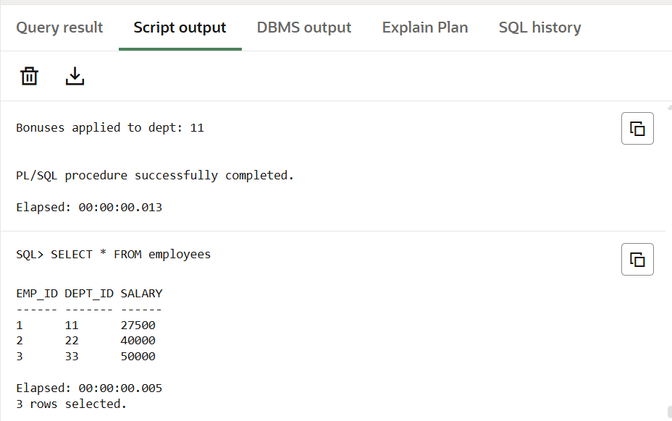

**Scenario 3:**

-- Scenario 3: Transfer Funds with Validation

CREATE OR REPLACE PROCEDURE TransferFunds (

p_from_acct IN acc_balances.acc_id%TYPE,

p_to_acct IN acc_balances.acc_id%TYPE,

p_amount IN NUMBER

) AS

v_balance NUMBER;

BEGIN

-- Fetch current balance

SELECT balance INTO v_balance

FROM acc_balances

WHERE acc_id = p_from_acct;

-- Validate

IF v_balance < p_amount THEN

RAISE_APPLICATION_ERROR(-20001, 'Insufficient funds in account ' || p_from_acct);

END IF;

-- Debit and credit

UPDATE acc_balances

SET balance = balance - p_amount

WHERE acc_id = p_from_acct;

UPDATE acc_balances

SET balance = balance + p_amount

WHERE acc_id = p_to_acct;

COMMIT;

DBMS_OUTPUT.PUT_LINE('Transferred ' || p_amount || ' from ' || p_from_acct || ' to ' || p_to_acct);

EXCEPTION

WHEN OTHERS THEN

ROLLBACK;

DBMS_OUTPUT.PUT_LINE('Transfer failed: ' || SQLERRM);

END TransferFunds;

/

-- Before transfer

SELECT * FROM acc_balances;

BEGIN

TransferFunds(101, 103, 5000);

END;

/

-- After transfer

SELECT * FROM acc_balances;

**Output Scenario3:**

